**USER GUIDE**

**IDENTITY ACCESS MANAGEMENT**

**Submitted by**

**Rahul Kumar Thai Valappil**

Epita Login- thaiva_r

Date: May -15-2016

Version: 1.0

**Table of Contents**

**1 Introduction………………………………………………………………………………………**

1.1 Scope and purpose…………………………………………………………………………………………

1.2 Process Overview ………………………………………………………………………………………

1.3 Configuration…………………………………………………………………………………………

**2 Process /Workflow……………………………………………………………**

**3. Appendices…………………………………………………………………………………………**

## 1. Introduction

### **1.1 Scope and Purpose**

The Identity Access Management System is an administrative application that deals with manipulation and management of individual identities, their authentication within or across system. The document helps to understand the basic routine working of the Identity access management and its functionalities.

### **1.2** Process Overview

A web based application accessed through web browser will have following main process.

**Identity Lifecycle Management:** The Application supports basic CRUD operation for Identities such as identity creation, reading, deletion and update.

**Authorization:** The process of determining if a user should have access to a system or function

**Configuration Management**: The process allows to configure user account with specific role and access level.

### 1.3 Configuration

Identity Management System needs to be configured to get a valid user authentication such as username and password. A valid license issued during the purchase will help to register an administrative user with fill access to the system.

## 2. Detailed Process Overview

The application involves the following processes which should be carefully understood for proper usage.

Processes:

* Configuration
* User Login
* Welcome Screen
* Identity Creation
* Identity Search
* Identity Update
* Identity Delete

**Configuration**

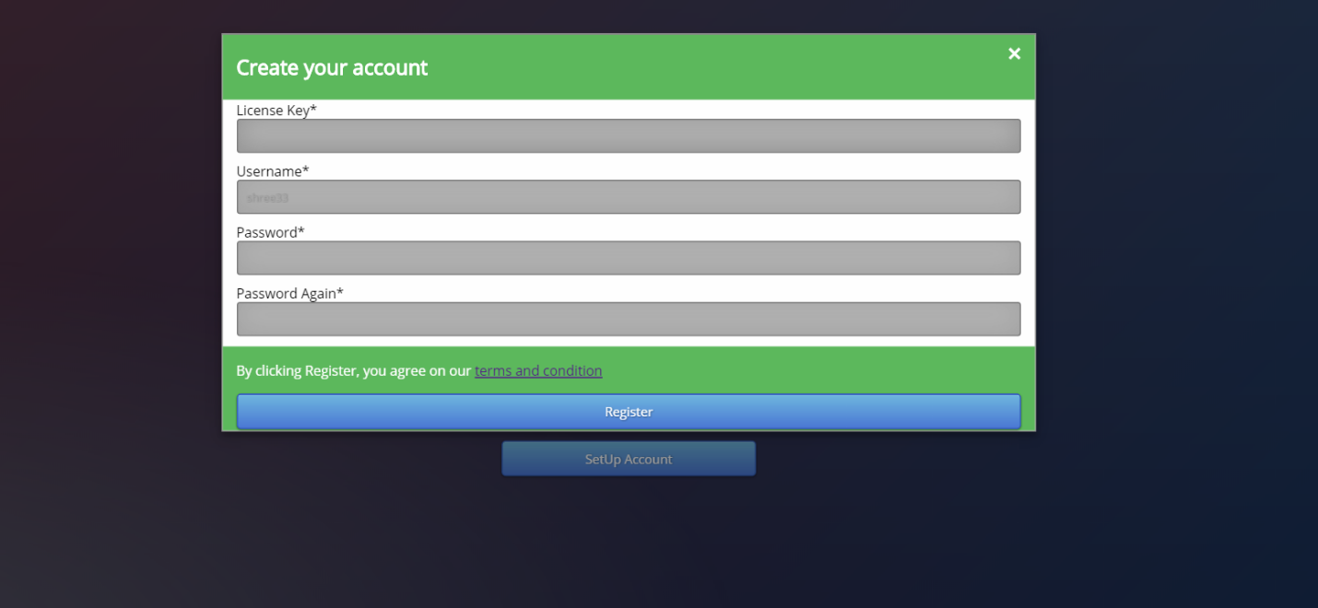

### User Login



### Welcome Screen

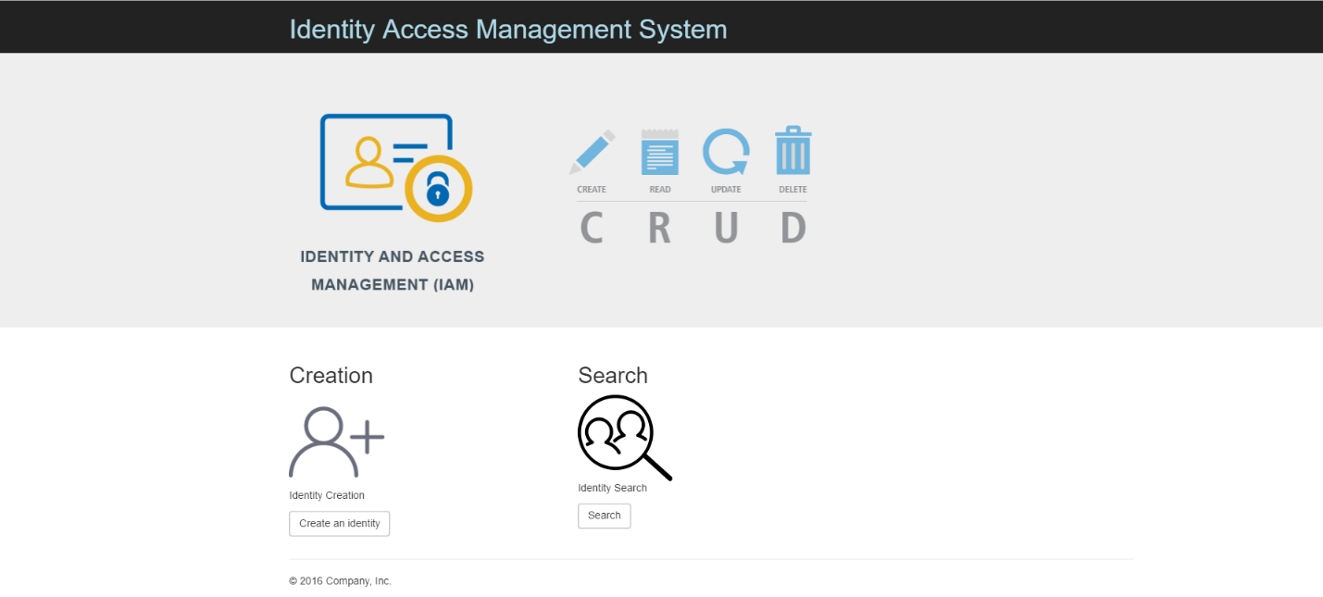

**Identity Creation**

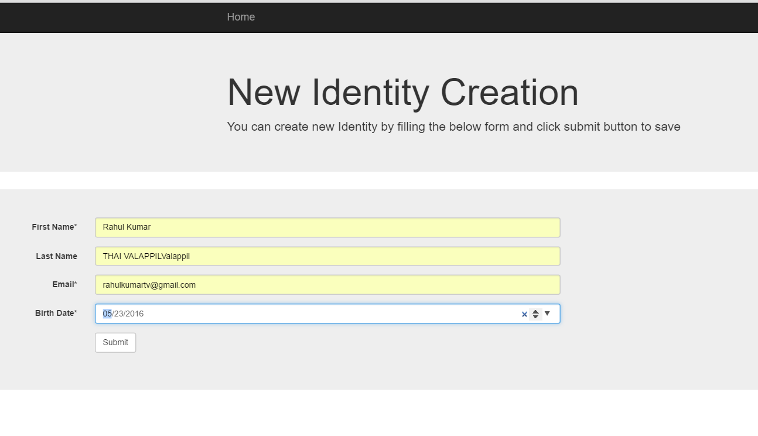

### Identity Search

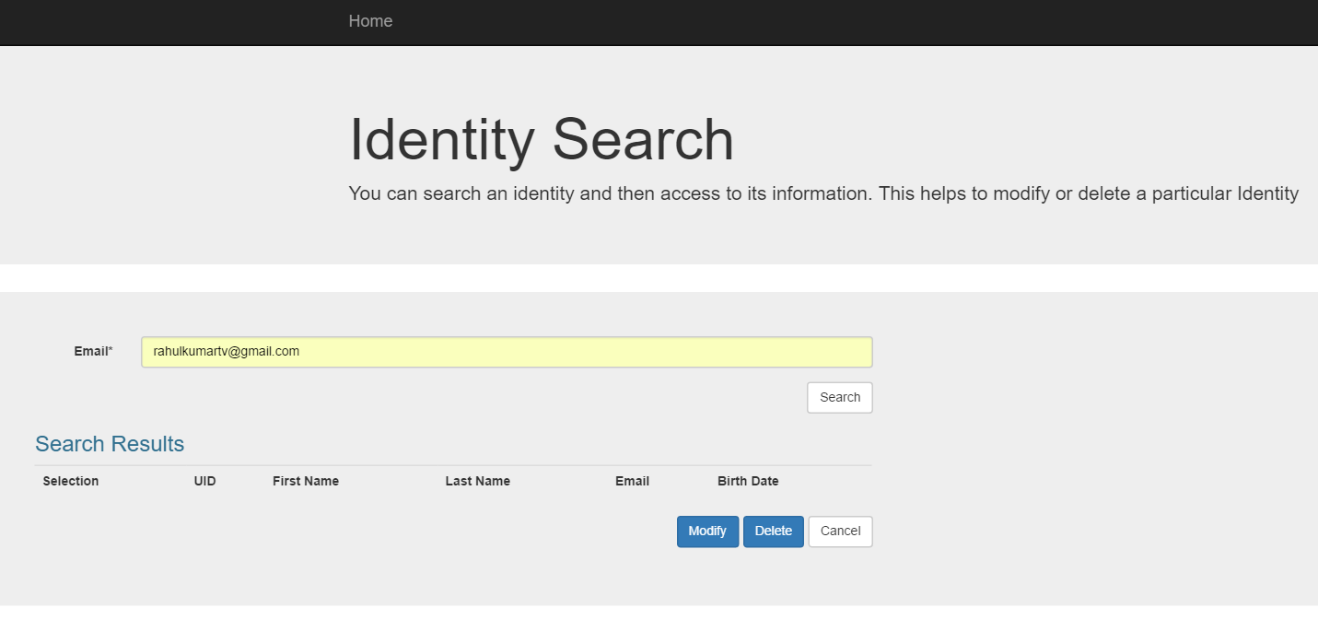

### Identity Update

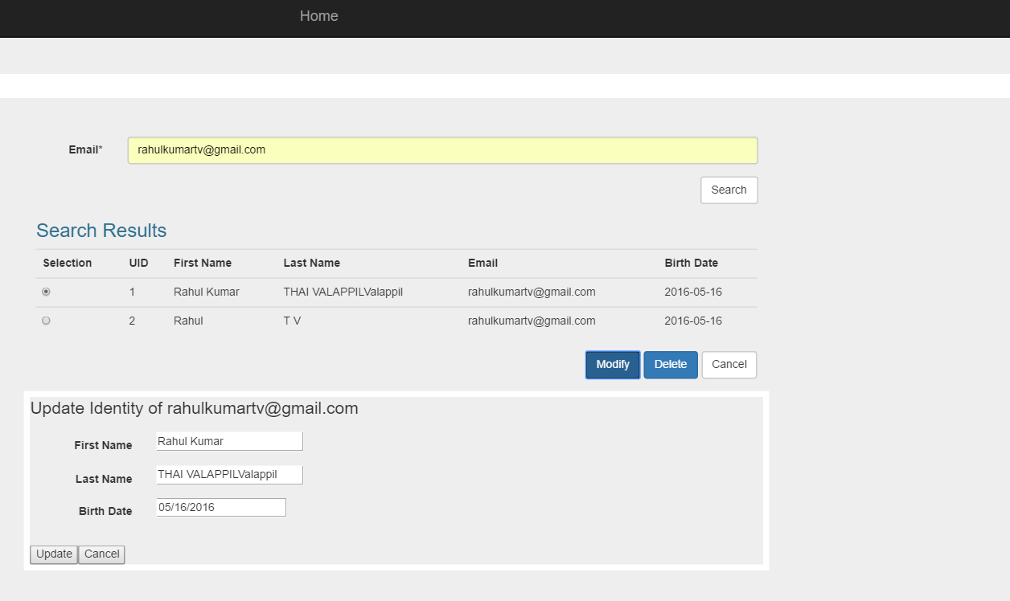

### Identity Delete

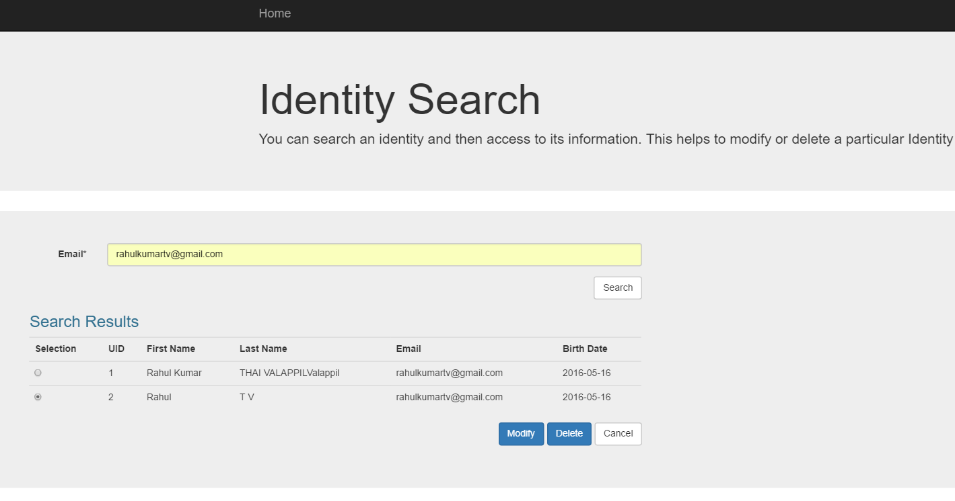

## 3. Appendices

The above application is platform independent however it requires Java run time environment and apache derby to be installed on the target machine/operating system to run